**Delivery Hero Data Engineer Interview Guide – Experienced 7+**

**Round 1: Get to Know**

**1. Can you tell me about your past experiences and projects?**

**Answer**:

Focus on impactful projects, highlighting tools, technologies, and quantifiable outcomes.

Example: *I worked on optimizing a real-time data pipeline using Apache Kafka and Spark, which reduced data processing time by 40%. Additionally, I led a cloud migration project from on-premises Oracle databases to Google Cloud, leveraging BigQuery and Dataproc.*

**2. What challenges did you face, and how did you tackle them? Answer**:

Use the STAR framework to structure your response.

Example: *In one project, we faced data skew issues with Spark jobs. I identified the issue using Spark UI and implemented salting techniques, which balanced the load across partitions and reduced job failures.*

**3. Why did you apply to Delivery Hero? Answer**:

Align your motivations with their mission and the role.

Example: *I admire Delivery Heros commitment to innovation in the food delivery space. The opportunity to work on scalable, real-time systems aligns with my expertise and passion for solving challenging data problems.*

**4. How do you keep up with learning? Have you attended any conferences or engaged in other learning activities?**

**Answer**:

Mention certifications, platforms, or events.

Example: *I recently completed the AWS Certified Data Analytics – Specialty certification and attended the Data + AI Summit 2024. I also regularly follow industry blogs and contribute to open-source projects.*

**Round 2: Hiring Manager**

**5. What does an ideal team look like to you?**

**Answer**:

*An ideal team promotes collaboration, innovation, and knowledge sharing while maintaining clear goals and accountability.*

**6. What kind of team would you prefer not to work with? Answer**:

*I prefer not to work in a team with poor communication or unclear priorities, as it can hinder productivity and growth.*

**7. How do you handle situations where you disagree with feedback from others? Answer**:

*I first seek to understand their perspective, provide data-driven insights to support my view, and collaborate to find the best solution.*

**8. Can you describe a challenge you faced and how you resolved it? Answer**:

*During a migration project, I faced schema mismatches between source and target systems. I resolved it by creating a mapping strategy and automating schema validation using Python scripts.*

**9. What is a mistake you made, and how did you overcome or resolve it? Answer**:

*In a data pipeline project, I underestimated resource requirements, causing delays. I resolved it by introducing dynamic resource allocation and ensuring better workload testing in subsequent projects.*

**10. How do you compare the time investment and value of a task? Answer**:

*I use the effort-impact matrix to prioritize tasks, focusing on high-impact and low-effort items first.*

**11. Can you describe a project you successfully accomplished? What did you do to achieve that success?**

**Answer**:

*In a recent project, I built a recommendation engine using Spark and MLlib, which improved product recommendations by 30%. The success was due to iterative improvements and effective collaboration with the team.*

**12. What metrics do you use to determine whether a Spark job is going well or not?**

**Answer**:

*Metrics like DAG stage duration, shuffle read/write size, executor memory usage, and task failure rates are crucial for monitoring Spark job performance.*

**13. How would you handle a schema change when new files arrive? Answer**:

*I use schema evolution with tools like Avro or Parquet and validate new schemas using automated checks. For breaking changes, I version schemas and update downstream dependencies accordingly.*

**Round 3: Technical - Coding and System Design**

**14. Write a Python code that determines if all the people in their seats can see the screen in the theatre.**

**Answer**:

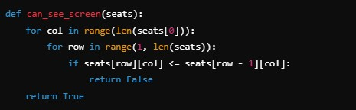

**15. Write a SQL query to find the second highest salary in each department. Answer**:

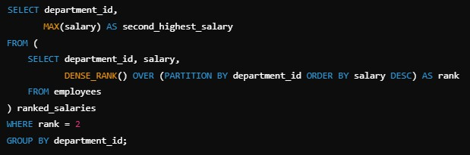

**16. How would you design a cost-effective, scalable, and efficient data pipeline for an e-commerce website?**

**Answer**:

*Use Kafka for ingestion, Spark for transformations, and Snowflake for storage. Optimize cost with spot instances and monitor using Prometheus/Grafana.*

**17. Apache Spark Questions**

• **What is data skewness?**

*Uneven distribution of data across partitions causing performance issues. Resolved with salting or partition pruning.*

• **Narrow vs Wide transformations**

*Narrow transformations operate within a single partition (e.g., map), while wide require shuffles across partitions (e.g., reduceByKey).*

**18. Airflow Questions**

• **What are XComs?**

*XComs allow task communication by passing small amounts of data between tasks in a DAG.*

**19. Kafka Questions**

• **What is offset management?**

*Offset management tracks consumer progress in reading messages from topics, ensuring fault tolerance and no duplicate processing.*

**Round 4: Technical - Bar Raiser**

**20. How would you implement a program to determine the frequency of each letter in a string?**

**Answer**:

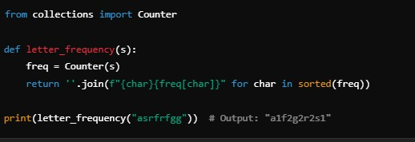

**21. Can you tell me about your past experiences and projects?**